Spatiotemporal buffering of alpine plant communities to microclimatic variation in northern Spain

Borja Jiménez-Alfaro, Eduardo Fernández-Pascual, Corrado Marcenó

# Abstract

**Questions**: In alpine landscapes, topography creates a mosaic of microclimatic niches which might prevent local extinctions through climate buffering. However, the magnitude of this buffering is poorly studied, limiting our understanding of climate change effects on alpine vegetation. Here we ask (1) how microclimatic factors influence the composition of local alpine communities across time and space, and (2) which microclimatic scenarios are more likely to drive local species extinctions.

**Location**: Relict alpine communities in Picos de Europa National Park, Spain.

**Methods**: We used data from a long-term monitoring project on four alpine sites with a 10-year record of species composition and microclimate. We sampled further spatial variation in composition and microclimate in 80 plots along the four sites. Climatic variation was evaluated through growing degrees-day (GDD) and freezing degrees-day (FDD) and four microclimatic conditions: hot-snowy, hot-frozen, cold-snowy and cold-frozen. We used the most extreme of these conditions recorded during the 10 years of monitoring as plausible scenarios to predict species extinctions.

**Results**: We found a temporal trend of temperature warming coupled with slight changes in the cover of winner and loser species. Microclimatic conditions were more homogeneous in time than space, with GDD showing higher variation in space than time. A total of 16 species (out of 86) responded significantly to spatial microclimatic variation. The scenario with the highest number of extinctions was hot-frozen (9), followed by hot-snowy (6), cold-frozen (6) and cold-snowy (1).

**Conclusions**: Our results suggest that spatial microclimatic refugia can compensate for temporal changes in temperature. However, a shift towards more Mediterranean conditions, with snow-free and frosty winters, will have the highest impact in local plant communities. With sufficient snow precipitation, the response of the study system to climate warming seems more likely to produce a re-accommodation of species relative abundances along topographical variation, as it could have occurred during the Holocene.

# 1. Introduction

Wneffnlandscapes, topography creates a mosaic of microclimatic niches which might prevent local extinctions

Bullet points:

* Climate impact on alpine communities is unclear
* Topographic buffering along meso-climatic gradients is well known
* We know little about the real impact of topography at the microscale, and whether termophilization or decrease in snowcover or frost frequencies influence alpine communities.
* We ask (1) whether microclimate variation measured in long-term vegetation monitoring is scalable with the spatial variation found in the microclimatic surroundings, and (2) what might be the impact of this variation on the abundance and composition of communities

Peter le Roux, Miska Luoto

-> Pekka Niitynen (snow)

-> Mia Momberg (wind)

soil moisture (GCB)

biotic interac / facilitation (ecology)

geomorpho (JVS)

Check TDR300 Field scout (soil mousture)

# 2. Methods

## 2.1 Study system

The study was conducted in the Cantabrian Mountains (Spain), a biodiversity hotspot for cold-adapted plants in the Iberian Peninsula and a biogeographical hub for Alpine and Mediterranean lineages in Western Europe (Jiménez-Alfaro et al. 2021). The study sites were placed in the central calcareous massif of the Picos de Europa National Park (**Fig. 1A**). This massif contains the highest elevations of the Cantabrian range, with alpine vegetation occurring between 1900 and 2400 m a.s.l., supporting a local species pool of XX species (Jiménez-Alfaro et al. 2014, JVS).

In 2008, we established a long-term ecological research program for monitoring soil climate and vegetation. The initial survey consisted of eight sites distributed in the calcareous massif along a North-South gradient to reflect major variation in vegetation types and local climatic gradients. From these, we excluded two sites placed in rocky outcrops and two sites subjected to grazing and human impact, which species composition is poor and less influenced by climate, respectively. The four study sites kept for this study (**Table 1**) follow the local climatic gradient (**Fig. 1B**) and they are representative of the two major vegetation types described in the study area (Jiménez-Alfaro et al. 2012).

## 2.2 Temporal survey

In each site, we buried a temperature logger (M-Log5W, GeoPrecision, Ettlingen, Germany; accuracy: +/- 0.1 ºC at 0 ºC, resolution: 0.01 ºC, records each hour) at 5 cm depth in a relatively flat and homogeneous vegetation patch. We surveyed the plant community in two replicated plots of 1 m2 separated 1 m from the logger, identifying species composition of vascular plants and estimating relative cover in %. For each 1 m2 plot, we sampled species frequency using a grid template of 100 microplots (10 cm x 10 cm) following the methodology of the Global Observation Research Initiative in Alpine Environments (GLORIA, Pauli et al. 2015). The loggers were replaced by new ones, when needed, to obtain a continuous temperature record from 2008 to 2018. In 2018, we re-surveyed the plots in the same way to detect changes in species presence and frequency. The vegetation data from these surveys, together with the soil temperature collected in the four study sites during 10 years, represent the “temporal survey.”

## 2.3 Spatial survey

In 2018, we visited the study sites to assess the spatial variation of vegetation and microclimate around the four plots sampled in the temporal survey. Using the long-term temperature logger as the central reference, we additionally placed 20 iButtons (Thermochron, iButton, Newbury, UK; accuracy: +/- 0.5 ºC from -10 ºC to +65 ºC, resolution: 0.5 ºC, records each 4 hours) in 20 plots of 1 m2 separated 10 m from each other along the four cardinal directions (**Fig. 1C**). For each one of these 20 plots, we identified all the vascular plants and estimated their relative cover in %. The recording period for the iButtons lasted from October 2018 to August 2019 (330 days). These data, together with the associated species data of the plots, represent the “spatial survey.”

## 2.4. Bioclimatic data

We used the microclimatic data of the temporal and spatial surveys to calculate several bioclimatic indices. For comparison, we homogenized the data at 4-hour intervals of the temporal survey, and the 330 calendar days covered by the spatial survey. In total, we obtained 40 data points for the temporal survey (4 sites * 10 years) and 80 for the spatial survey (4 sites x 20 plots).

The bioclimatic indices were based on standard variables like WorldClim (Fick and Hijmans 2017), and additional variables reflecting snow cover, growing degree days (Bürli et al. 2021) and frost degree days (Choler 2018), as they were supposed to have a relevant effect on alpine topoclimatic gradients. They were: (1) bio1 = annual mean temperature; (2) bio2 = mean diurnal range, i.e. the mean of the monthly differences between maximum and minimum temperatures; (3) bio7 = temperature annual range; i.e. the difference between the maximum temperature of the warmest month and the minimum temperature of the coldest month; (4) snow = the number of days of snow cover, considered to be those days in which the maximum temperature was below 0.5 ºC and the minimum temperature was above -0.5 ºC; (5) GDD = growing degrees-day, i.e. the sum of daily mean temperatures for days in which the mean temperature was above 1 ºC; and (6) FDD = freezing degrees-day, i.e. the sum of daily mean temperatures for days in which the mean temperature was below 0 ºC. For FDD, we transformed the values from negative to positive (higher values equal more freezing).

After 10 years of soil temperature monitoring (**Fig. 2A**), two of the sites (Los Cazadores and Los Boches) showed a consistent pattern of continuous snow cover during winter (i.e. snowbed conditions reflected by temperature records around 0 ºC). In contrast, the two other sites (Ḥou Sin Tierri and Hoyo Sin Tierra) showed repeated frost (below 0ºC) temperatures during winter (i.e. fellfield conditions). Such differences were associated with contrasting conditions of annual temperature, GDD and FDD along the four sites (**table 1**). Soil temperature of the spatial surveys also showed variation between snowbed and fellfield conditions (**Fig. 2B**). Within each site, the length of snow cover across plots ranged from 0 days under snow (with frost temperatures during the whole year) to 8 months (with a maximum of 234 days, from November to July). The annual range of temperatures varied from 17.8 ºC to 30.3 ºC, and the diurnal range from 1.6 ºC to 5.5 ºC. The absolute maximum was 33 ºC, the absolute minimum -12 ºC. GDD ranged from 517 ºC to 1,612 ºC and FDD from 0 ºC to 206 ºC.

Along the NMDS computed for the 80 plots of the spatial surveys (**Figure 5**), we identified four major climatic conditions: Hot & Snowy, Cold & Snowy, Hot & Frozen, and Cold & Frozen. The study sites were poorly differentiated, although one site (Los Boches) was more represented in the Cold & Frozen space (Supplement **S1**). According to this, we created four plausible scenarios corresponding to the maximum and minimum values recorded during the 10 years of monitoring: hot and snowy (max GDD = 2069 ºC, min FDD = 0 ºC), hot and frozen (max GDD = 2069 ºC, max FDD = 247 ºC), cold and snowy (min GDD = 570 ºC, min FDD = 0 ºC) and cold and frozen (min GDD = 570 ºC, max FDD = 247 ºC).

## 2.5. Plant species data

Across the whole study system (temporal and spatial surveys) we recorded 86 taxa of vascular plants, representing % of the local species pool of the study area. Of these, 81 species were in the spatial survey plots, and 48 in the temporal survey plots. The five most frequent species were *Thymus praecox* subsp. *ligusticus* (83 occurences), *Anthyllis vulneraria* (73), *Koeleria vallesiana* (59), *Minuartia verna* (55) and *Helianthemum canum* (52). In the temporal survey (2 visits x 2 plots per site, n = 16) we recorded 42 species in 2009 and 47 in 2019.

## 2.6. Data analyses

All analyses were conducted with R (R Core Team 2021) and the code is available at GitHub (see Data Availability Statement). First, we evaluated the overall microclimatic variation at the study sites by plotting their temperature data series across years (for the temporal survey) and microsites (for the spatial survey). For each site, we also conducted a principal component analysis (PCA) (Lê *et al.* 2008) of the bioclimatic indices to identify the main gradients of microclimatic variability at both temporal and spatial surveys. To compare the width of the microclimatic variability in time and space we calculated, for each site, the difference between the maximum and minimum values of GDD and FDD (and snow?) in time (max and min values in 10 years per site) and space (max and min values in 20 plots per site), as they were the variables with the highest contributions to the PCAs.

We used non-metric multidimensional scaling (NMDS) with environmental fitting (Oksanen *et al.* 2019) to assess the whole variation in species composition based on the spatial survey (80 plots), and their relation to GDD and FDD. These variables provided the strongest fit with the first PCA axes conducted for the environmental data of the whole data set (Supplement **S1**), showing a first gradient of thermicity (GDD, bio1, bio2 and bio7) and a second gradient of freezing (FDD). Then, we used the temporal survey data to construct scenarios of climate change using the extreme values of the last 10 years (2009-2018). To do so, we calculated, for GDD and FDD, the maximum and minimum values recorded in the entire period (see results) and created scenarios with a clear interpretation in the NMDS (see results). We finally used Generalized Linear Models (GLMs, binomial family) to predict the probability of occurrence for each species and scenario, considering that a probability of 0 in a scenario would mean the extinction of the species. The predictions were computed for each plot (n = 78, we removed two plots placed in rocks with no vascular plants) as a response to the plot’s values of GDD and FDD. We only modeled species with at least 10 occurrences in the plots, keeping the models in which at least one of the bioclimatic indices had a significant effect size (p < 0.05) and for which the value of McFadden’s pseudo R2 (McFadden 1974) was higher than 0.15 – since McFadden’s pseudo R2 tends to have lower values than R2 in ordinary least squares regression, values between 0.2 and 0.4 represent very good fit (McFadden 1979).

# 3. Results

## 3.1. Temporal trends

Three species were not found in the resurvey (*Festuca burnatii*, *Galium pyrenaicum* and *Iberis carnosa*) and other eight species were recorded for the first time (*Arenaria purpurascens*, *Lotus corniculatus*, *Potentilla crantzii*, *Sedum album*, *Sedum brevifolium*, *Seseli montanum*, *Silene ciliata* and *Solidago virgaurea*). The five species with the highest decrease in frequency from 2009 to 2019 (ignoring annual species and species that occurred in less than 10 10x10 cm cells in 2009) were *Armeria cantabrica* (85% decrease in frequency, present in 13 cells in 2009), *Poa alpina* (-83%, 18 cells), *Salix breviserrata* (-48%, 25 cells), *Jurinea humilis* (-26%, 23 cells) and *Ranunculus parnassiifolius* subsp. *favargeri* (-18%, 72 cells). The five species with the highest increases (again, ignoring annual species and species that occurred in less than 10 10x10 cm cells in 2009) were *Minuartia verna* (+278%, 19 cells), *Helianthemum apenninum* subsp. *urrielense* (+87%, 63 cells), *Arenaria moehringioides* (+85%, 13 cells), *Saxifraga conifera* (+83%, 24 cells) and *Silene acaulis* (+39%, 18 cells). In the spatial survey, the average species richness per 1m2 plot was 13, with the richest plot having 25 species and the poorest two species.

## 3.2 Space vs. time

Calcular climatic rescue potential: usar los valores GDD y FDD de cada sitio para calcular la SD y 95% CI del sitio, con esto se puede estimar el potencial del climatic rescue

The bioclimatic characterization along the PCA axes showed a certain differentiation between the temporal and the spatial surveys for each study site (**Figure 3**). However, the climatic amplitude covered by the two data sets were relatively similar (calculate PCA loadings for each group), especially along the first PCA axes. When comparing the maximum differences between the two surveys, the spatial differences for GDD were larger than the temporal ones (**Figure 4**), but the difference was only marginally different (paired t-test, one.sided, t = 1.945, df = 3, p-value = 0.073). For FDD, the two differences were not significantly different (paired t-test, one.sided, t = -0.29029, df = 3, p-value = 0.6047). Add snow cover.

## 3.3. Species extinction probability

From the 81 species recorded in the spatial surveys, 36 had more than 10 occurrences, and we included them in the GLM modeling (full model results in supplementary material **S2**). For 16 of these species, we produced models with a sufficient effect size to be considered relevant (i.e. at least one of the two bioclimatic indices had a significant effect size and the value of McFadden’s pseudo R2 was higher than 0.15). But how many were significant…? The predictions (**Table 2**) show that some species survived only in either the hot scenarios (e.g. *Androsace villosa*), the cold scenario (e.g. *Festuca glacialis*) or the snowy scenarios (e.g. *Alchemilla catalaunica*). The cold & snowy scenario produced the lowest number of species extinctions and the hot & frozen scenario the higher rate of extinctions, with the cold & frozen and the hot & snowy scenarios producing intermediate numbers (**Figure 5**). The species with the strongest decreases in the temporal surveys (e.g. *Armeria cantabrica*, *Euphrasia salisburgensis*, *Galium pyrenaicum*) were associated with higher extinction in the snowy conditions. (we need to incorporate snow in the plot to interpret snow…)

# 4. Discussion

Differences between life forms, chorology

Why FDD and GDD are orthogonal?

# DATA AVAILABILITY

The original data, R code for the analysis and creation of the manuscript can be accessed at the GitHub repository <https://github.com/efernandezpascual/picos>. A version of record of the repository is deposited in Zenodo.

# LITERATURE CITED

**Bürli S, Theurillat J-P, Winkler M, *et al.*** **2021**. A common soil temperature threshold for the upper limit of alpine grasslands in European mountains. *Alpine Botany* **131**: 41–52.

**Fick SE, Hijmans RJ**. **2017**. WorldClim 2: new 1-km spatial resolution climate surfaces for global land areas. *International Journal of Climatology* **37**: 4302–4315.

**Lê S, Josse J, Husson F**. **2008**. FactoMineR: an R package for multivariate analysis. *Journal of Statistical Software* **25**: 1–18.

**McFadden D**. **1974**. Conditional logit analysis of qualitative choice behavior In: Zarembka P, ed. *Frontiers in Econometrics*. Cambridge, MA: Academic Press, 105–142.

**McFadden D**. **1979**. Quantitative methods for analyzing travel behaviour on individuals: Some recent developments In: Hensher D, Stopher P, eds. *Behavioural Travel Modelling*. London, UK: Routledge, 48.

**Oksanen J, Blanchet FG, Friendly M, *et al.*** **2019**. vegan: Community Ecology Package. R package version 2.5-6.

**R Core Team**. **2021**. R: a language and environment for statistical computing. Version 4.1.1.

**Table 1.** Descriptive statistics of microclimatic data recorded in the temporal survey (from 2008 to 2018) in four alpine sites of Picos de Europa National Park, Spain.

|  |  |  |  |  |
| --- | --- | --- | --- | --- |
|  | Los Cazadores  (snowbed) | Hou Sin Tierru  (fellfield) | Los Boches  (snowbed) | Hoyo sin Tierra  (fellfield) |
| Elevation |  |  |  |  |
| Annual snow cover |  |  | 193 days | 72 days |
| Mean annual Temp |  | 6.2 ºC | 3.8 ºC |  |
| Temp annual range |  | 23.8 ºC | 19.4 ºC |  |
| Diurnal Temp range |  | 3 ºC | 2 ºC |  |
| Absolute Temp (min/max) | ºC | ºC | ºC | ºC |
| Average annual GDD |  |  | 930 ºC | 1,711 ºC |
| Average annual FDD | 3 ºC | 89 ºC | 26 ºC | 100 ºC |

**Table 2.** Summary of the GLM models of species occurrences.

| Taxon | GDD estimate | GDD p | FDD estimate | FDD p | rho2 | Cold & Frozen | Cold & Snowy | Hot & Frozen |  | Hot & Snowy | Frequency 2009 | Frequency 2018 |
| --- | --- | --- | --- | --- | --- | --- | --- | --- | --- | --- | --- | --- |
| Alchemilla catalaunica | 0.00 | 0.174 | -0.06 | 0.035 | 0.20 | 0 | 17 | 0 |  | 74 |  |  |
| Androsace villosa | 0.01 | <0.001 | -0.01 | 0.376 | 0.49 | 0 | 0 | 100 |  | 100 | 17.6 | 17.2 |
| Arabis alpina | -0.01 | 0.004 | -0.01 | 0.396 | 0.22 | 25 | 60 | 0 |  | 0 |  |  |
| Arenaria grandiflora | 0.00 | 0.004 | -0.01 | 0.272 | 0.18 | 22 | 62 | 0 |  | 0 |  |  |
| Arenaria moehringioides | -0.01 | 0.001 | 0.01 | 0.03 | 0.34 | 97 | 60 | 0 |  | 0 | 1.6 | 3 |
| Armeria cantabrica | -0.01 | <0.001 | -0.01 | 0.029 | 0.39 | 65 | 98 | 0 |  | 0 | 1.6 | 0.2 |
| Carex sempervirens | 0.00 | 0.007 | -0.02 | 0.007 | 0.18 | 1 | 38 | 36 |  | 97 | 11.2 | 9.8 |
| Erigeron alpinus | 0.00 | 0.972 | -0.06 | 0.035 | 0.19 | 0 | 34 | 0 |  | 33 | 0.2 | 0.8 |
| Euphrasia salisburgensis | 0.00 | 0.11 | 0.03 | <0.001 | 0.32 | 91 | 1 | 100 |  | 33 | 4.4 | 3.2 |
| Festuca glacialis | -0.02 | 0.001 | 0.01 | 0.278 | 0.67 | 100 | 100 | 0 |  | 0 |  |  |
| Festuca hystrix | 0.01 | <0.001 | 0.00 | 0.644 | 0.30 | 0 | 1 | 98 |  | 99 | 17.1 | 17.9 |
| Galium pyrenaicum | 0.00 | 0.9 | 0.03 | <0.001 | 0.37 | 95 | 2 | 96 |  | 3 | 0.9 | 0 |
| Helianthemum canum | 0.01 | <0.001 | -0.01 | 0.333 | 0.40 | 1 | 3 | 100 |  | 100 | 56.2 | 59.2 |
| Iberis carnosa | 0.00 | 0.023 | 0.02 | <0.001 | 0.27 | 98 | 26 | 21 |  | 0 | 0.2 | 0 |
| Lotus corniculatus | 0.00 | 0.045 | -0.04 | 0.05 | 0.18 | 0 | 10 | 0 |  | 85 | 0 | 0.1 |
| Scilla verna | 0.00 | 0.006 | -0.05 | 0.035 | 0.25 | 0 | 6 | 0 |  | 96 | 6.2 | 7 |

**Figure 1.** Study system.

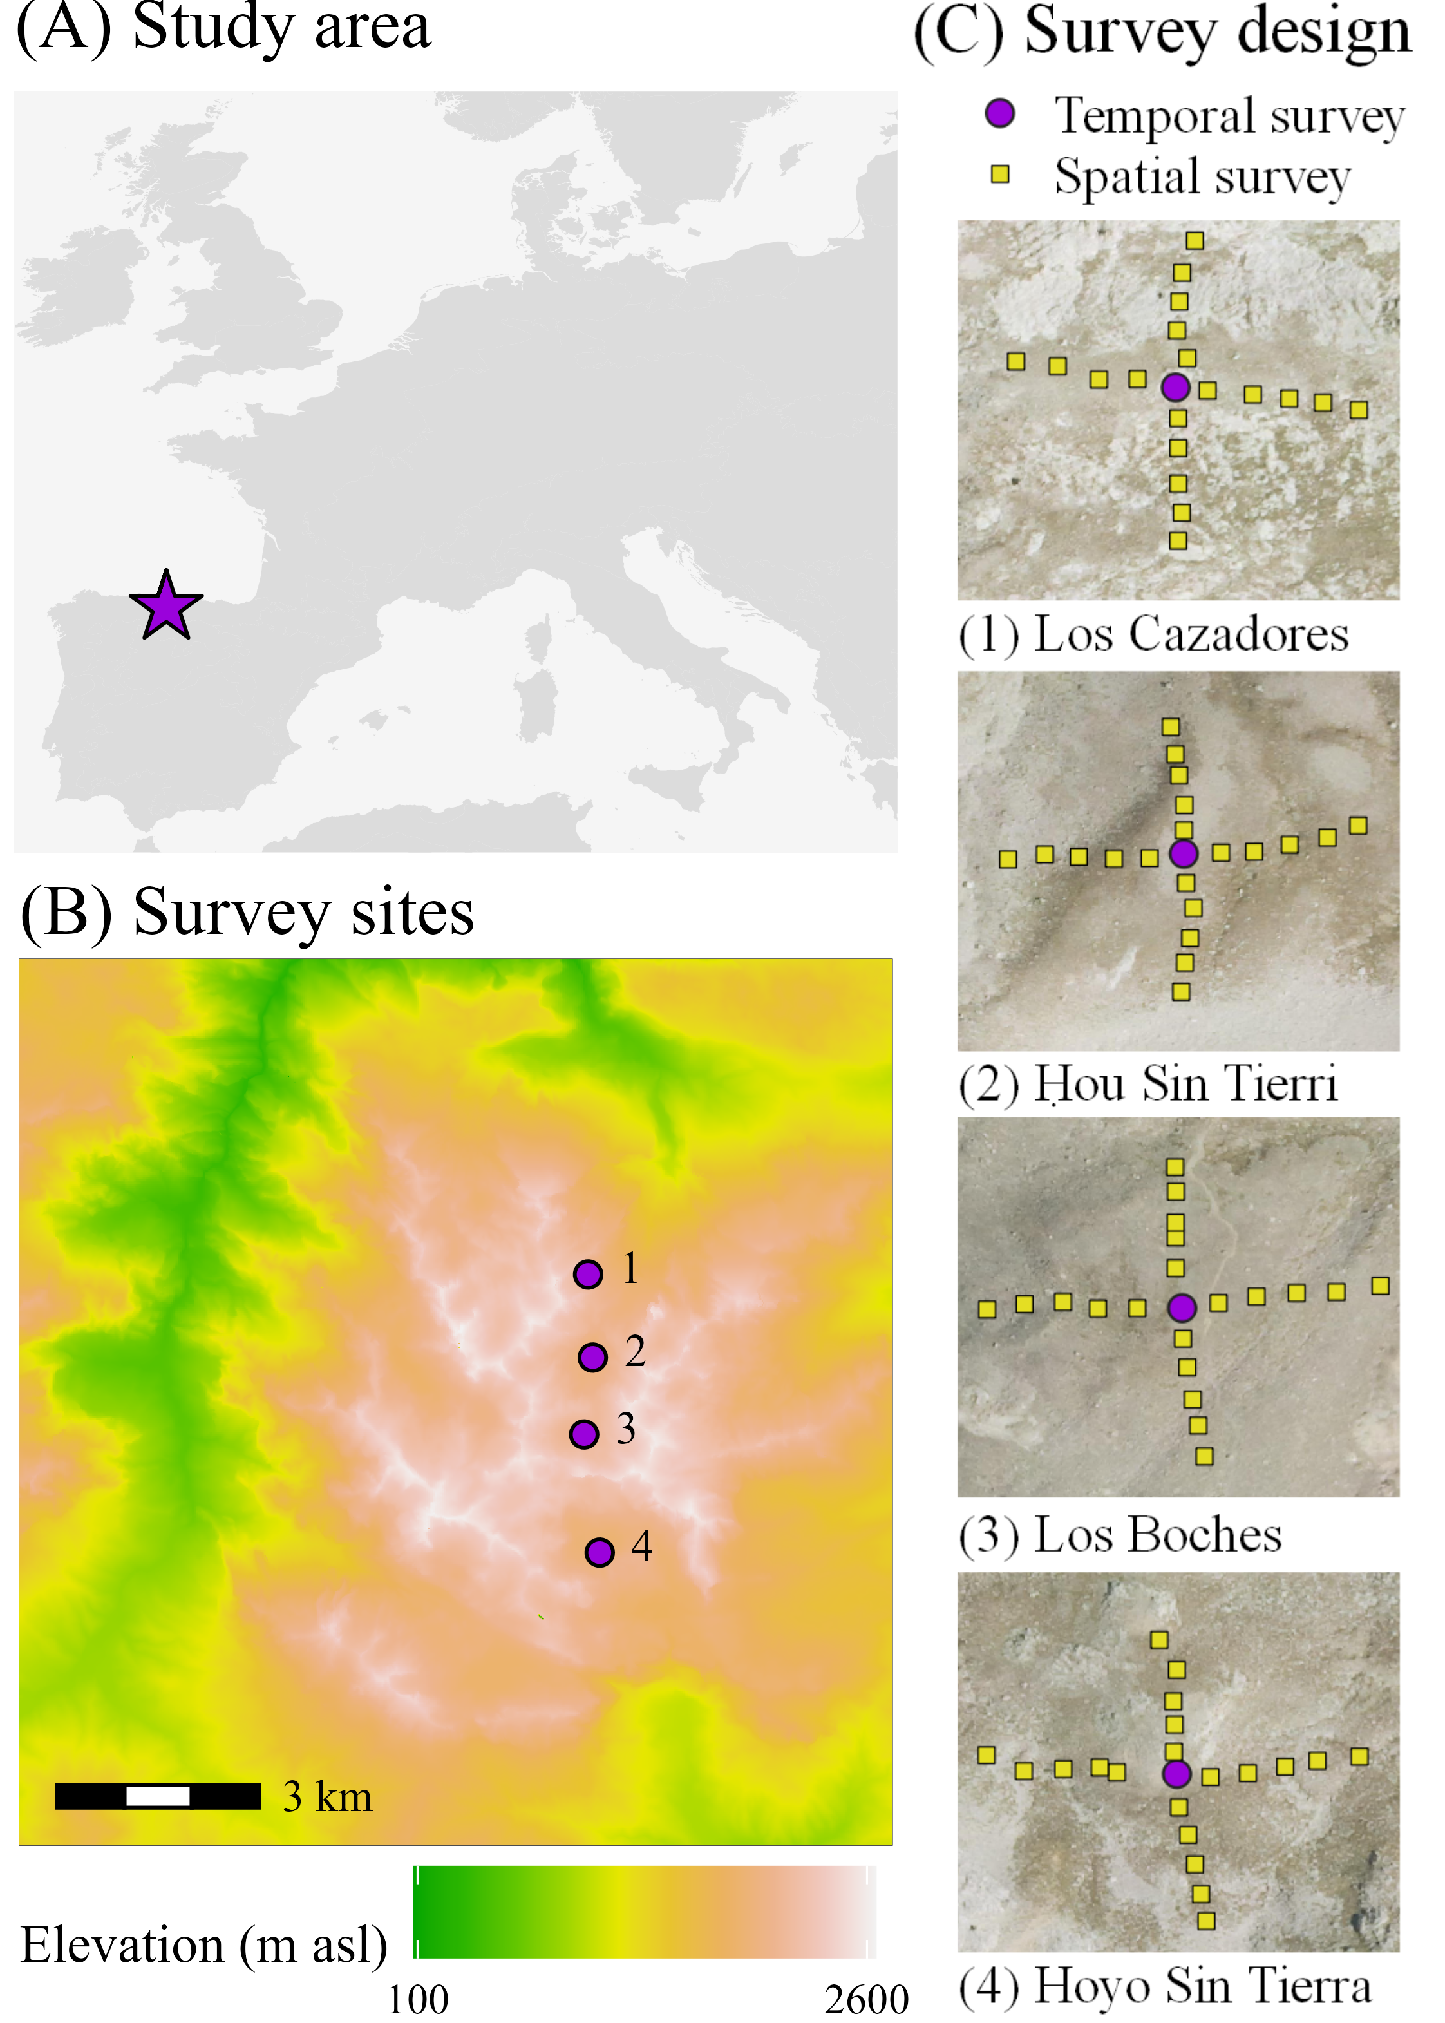

Figure 2.

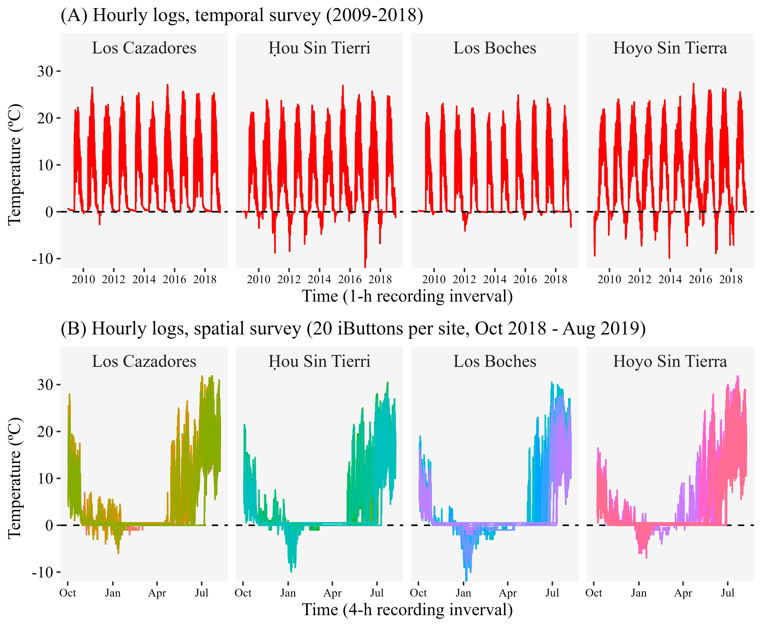

Figure 3. xxx

Figure 4. xxx

Add snow. Sholdn´t be the graphs for eacth site? Delete (B)

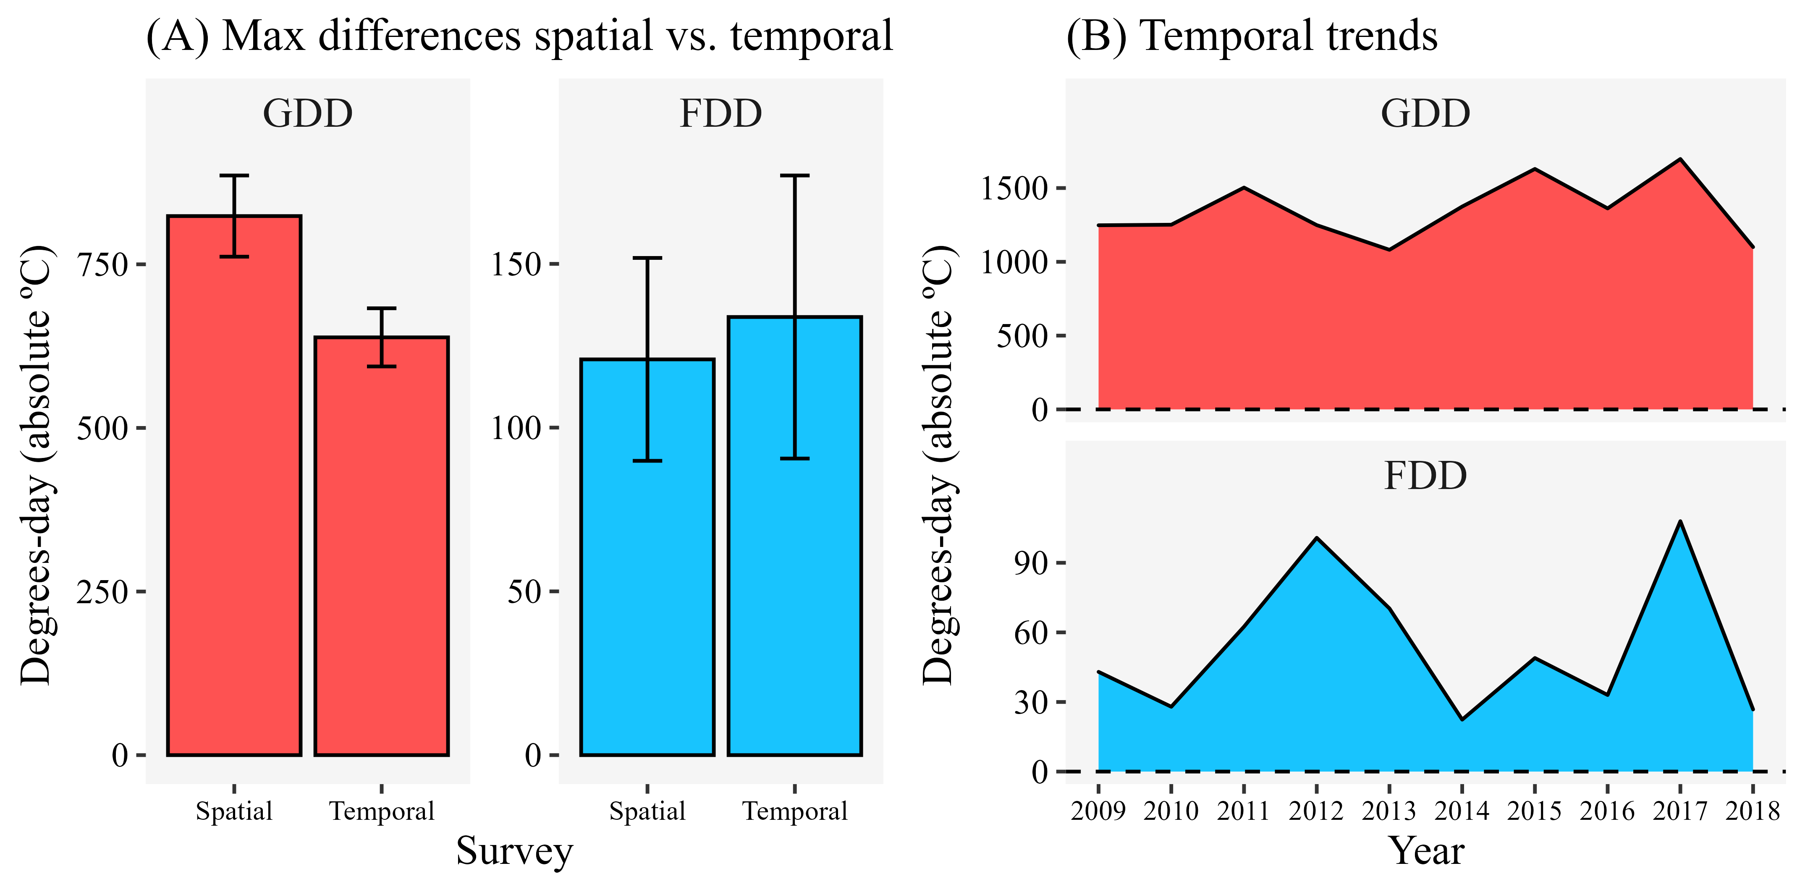

Figure 5. xxx

|  |  |
| --- | --- |
| Simplified version, color by scenarios  Figure 1 Study system. | Trends + photos?  Figure 1 Study system. |

**Figure S1.** Version only with the sample sites, NOT the scenarios. Compositional variation of only78 1 m2 plots surveyed in alpine communities of Picos de Europa National Park (Spain) in 2018 (spatial sampling) according to a Non-Metric Dimensional Scaling (NMDS). The vectors represent the environmental fitting of growing degree days (GDD, p < 0.001, R2 = 0.778) and freezing degree days (FDD, p < 0.001, R2 = 0.330) to the first (NMDS1) and second (NMDS2) axes, respectively.

